**Difference Between Edge Computing and Fog Computing**

Nowadays, a massive amount of data is generated every second around the globe. Businesses collect and process that data from the people and get analytics to scale their business. When lots of organizations access their data simultaneously on the remote servers in data centers, data traffic might occur. Data traffic can cause some delay in accessing the data, lower bandwidth, etc. But [cloud computing](https://www.geeksforgeeks.org/cloud-computing/) technology alone is not effective enough to store and process massive amounts of data and respond quickly.

*For example,*in the Tesla self-driving car, the sensor constantly monitors certain regions around the car. If it detects an obstacle or pedestrian on its way, then the car must be stopped or move around without hitting. When an obstacle is on its way, the data sent through the sensor must be processed quickly and help the car to detect before it hits. A little delay in detection could be a major issue. To overcome such challenges, [edge computing](https://www.geeksforgeeks.org/edge-computing/) and [fog computing](https://www.geeksforgeeks.org/fog-computing/) are introduced.

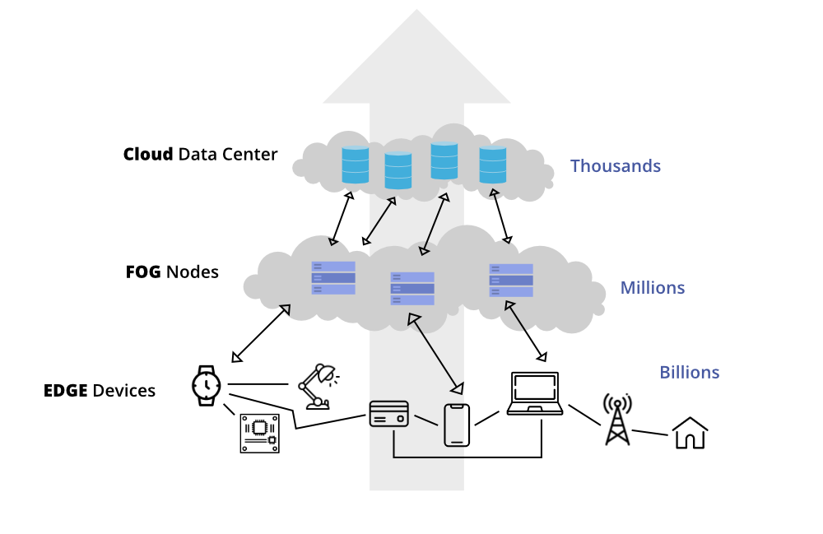

*Edge and Fog Computing*

**Edge Computing**

Computation takes place at the edge of a device’s network, which is known as edge computing. That means a computer is connected with the network of the device, which processes the data and sends the data to the cloud in real-time. That computer is known as “[edge computer](https://www.geeksforgeeks.org/what-is-edge-computing-and-its-importance-in-the-future/)” or “edge node”.

With this technology, data is processed and transmitted to the devices instantly. Yet, edge nodes transmit all the data captured or generated by the device regardless of the importance of the data.

**Example of Edge computing:**

* Autonomous vehicle edge computing devices collect data from cameras and sensors on the vehicle, process it, and make decisions in milliseconds, such as self-parking cars.
* In order to accurately assess a patient’s condition and foresee treatments, data is processed from a variety of edge devices connected to sensors and monitors.

Here ***Fog Computing*** was introduced and becomes an ideal solution.

**Fog Computing**

Fog computing is an extension of cloud computing. It is a layer in between the edge and the cloud. When edge computers send huge amounts of data to the cloud, fog nodes receive the data and analyze what’s important. Then the fog nodes transfer the important data to the cloud to be stored and delete the unimportant data or keep them with themselves for further analysis. In this way, fog computing saves a lot of space in the cloud and transfers important data quickly.

**Difference Between Edge Computing and Fog Computing**

| **S.NO.** | **EDGE COMPUTING** | **FOG COMPUTING** |
| --- | --- | --- |
| **01.** | Less scalable than fog computing. | Highly scalable when compared to edge computing. |
| **02.** | Billions of nodes are present. | Millions of nodes are present. |
| **03.** | Nodes are installed far away from the cloud. | Nodes in this computing are installed closer to the cloud(remote database where data is stored). |
| **04.** | Edge computing is a subdivision of fog computing. | Fog computing is a subdivision of cloud computing. |
| **05.** | The bandwidth requirement is very low. Because data comes from the edge nodes themselves. | The bandwidth requirement is high. Data originating from edge nodes is transferred to the cloud. |
| **06.** | Operational cost is higher. | Operational cost is comparatively lower. |
| **07.** | High privacy. Attacks on data are very low. | The probability of data attacks is higher. |
| **08.** | Edge devices are the inclusion of the IoT devices or client’s network. | Fog is an extended layer of cloud. |
| **09.** | The power consumption of nodes is low. | The power consumption of nodes filter important information from the massive amount of data collected from the device and saves it in the filter high. |
| **10.** | Edge computing helps devices to get faster results by processing the data simultaneously received from the devices. | Fog computing helps in filtering important information from the massive amount of data collected from the device and saves it in the cloud by sending the filtered data. |

## **IIoT definition**

IIoT stands for the Industrial Internet of Things, and as the name suggests it refers to the use of Internet of Things technology (connected machines, devices, and sensors) in industrial applications. When run by a modern ERP with AI and machine learning capabilities, the data generated by IIoT devices can be analyzed and leveraged to improve efficiency, productivity, visibility, and more. IIoT networks typically support machine-to-machine (M2M) communication and the regular transmission of data between the central system and all IIoT-integrated devices. IIoT technology is also a fundamental component of Industry 4.0 technologies.

## **IIoT vs IoT**

The differences between these technologies lies less in how they work and more in how they are used. The bulk of the world’s IoT solutions tend to have individuals as their end users and are most commonly incorporated into things like smart watches, voice-controlled digital assistants, or smart appliances and TVs.

IIoT is a subset of IoT, and, while it is driven by the same basic technologies, its focus is much more on automation and efficiency across an entire, connected organizational ecosystem – as opposed to an isolated user. In IIoT networks, gathering and curating data is only the first step in a more complex process. To provide maximum benefit to a business, artificial intelligence and machine learning must be applied to that data to deliver accurate insights and to optimize workflows and automated tasks. Human users must also be able to interact with these devices as seamlessly as possible to create cyber-physical networks in which the best of human and technological abilities can augment each other.

## **How it works: IIoT technology**

For an IIoT network to be effective, it must do two essential things: connect devices and assets to each other and a central system; and make it possible for the data they gather and transmit to be stored, managed, analyzed, and put to good use.

To do so, IIoT networks rely on the following technologies:

* **Connectivity (and 5G):** IIoT networks need the capacity to send and receive the massive volumes of data generated by machines and devices. This has traditionally been both enabled and limited by the power of Wi-Fi connectivity. But 5G and other advances in cellular networks are changing this calculus, increasing bandwidth to manage larger data sets, while also reducing latency and power consumption. These characteristics can support a greater number of devices capable of sending and receiving signals faster for more efficient data processing and longer battery life.
* **IIoT sensors**: Today, sensors are typically built into new industrial equipment and machinery.  But analog machinery and manufacturing equipment can also be fitted with IoT gateway devices such as cameras and gauges. This lets IIoT assets detect conditions in their environment, including the proximity of other objects, air pressure or humidity – as well as motor speed, fluid levels, and other mechanical conditions. All of this information can then be processed locally to inform real-time actions or be transmitted to a central system (such as an ERP) via the cloud for advanced analysis.
* **Cloud computing power and edge computing**: Both cloud and edge computing technologies have greatly improved the flexibility and usability of IIoT. Via the cloud, IIoT networks can leverage a high degree of processing power and storage capacity on demand. This means that devices within the network can gather and transmit larger and more complex data sets. Edge computing simply means taking systems that can process and analyze that data and bringing them on-premise – physically closer to the IIoT network. This helps reduce latency and delays and allows time sensitive IIoT data to be processed in real time. For deeper, less urgent analysis, IIoT data can be periodically sent to the central, AI-powered system.
* **AI and machine learning:** Artificial intelligence and machine learning technologies make it possible for businesses to process IIoT data using advanced and predictive analytics. Modern databases and machine learning algorithms also help businesses to manage and make sense of diverse data sets and unstructured and complex data. With these tools, IIoT data can be analyzed in almost limitless combinations with other types of data insights such as customer feedback, weather reports, marketing analytics, and more. As systems learn over time and as data sets get bigger and more precise, companies can begin to gather increasingly complex and sophisticated insights and learnings to help them compete, save money, and meet customer demands.
* **Security for cyber-physical systems:**The same connectedness that gives life to IIoT networks also puts them at risk. While most companies have tight security and access protocols around their central systems and databases, their IoT devices are sometimes relatively unprotected. Essentially, they can act as basement windows, giving full access to a system that is otherwise fairly secure via its conventional entry points. Fortunately, security protocols and technologies are largely keeping up with IIoT advancements. What often lags behind, however, are cross-business security protocols that are clearly communicated and reinforced to every employee and operator. If they aren’t already, security strategies must become a top priority for any modern business.

## **Top six benefits of IIoT and cyber-physical systems**

As part of an overall process of digital transformation, an IIoT network provides a powerful tool for building greater resilience and competitiveness.

1. **Improved business agility:** When IIoT devices share data in real-time, they contribute to an intelligence network that continually gathers, analyzes, and learns from data. This allows businesses to respond to opportunity – and risk – with speed and decisiveness. And those same devices not only send data but can also receive instructions based on data analysis to adapt and optimize their automated workflows.
2. **Healthier machines:** Devices and machines in an IoT network are continually transmitting operational logs and performance data. AI and machine learning algorithms use this sensor data to gain valuable insights into predictive and other maintenance needs, which can lead to significant cost savings. In fact, according to McKinsey, “Predictive maintenance typically reduces machine downtime by 30% to 50% and increases machine life by 20% to 40%.”
3. **Greater efficiency:** Unfortunately, “if it ain’t broke” is often the stance that businesses take when prioritizing their operational needs. This attitude can lead to inefficient legacy processes hanging on past their prime. The application of advanced analytics to IIoT data leads to ongoing recommendations and strategies for updating processes, streamlining workflows, and achieving increased efficiency and productivity.
4. **Smarter inventory management:** Today’s customers want next-day delivery and ever-increasing variety and customization. This means a bigger network of smaller, more distributed warehouses and a broader inventory with more individual items. IIoT devices can help to hook up all these geographically spread-out warehouses, inventories, and delivery networks – giving supply chain managers (and customers) a real-time idea of where inventories are at all times. And for some products, devices, such as additive (3D) printers, can reduce dependency upon remote manufacturers, allowing businesses to retain virtual inventories and manufacture the products they need – on demand and on site.
5. **Safer workers:**  In any industrial setting, there is always the danger of injury or strain. Today, many businesses are reducing this risk with the use of IoT workplace safety devices. These may deliver warnings via wearable sensors or use VR headsets to help workers merge their sensory experiences with the precision of smart devices and machines. In manufacturing settings, IIoT devices can also be fitted with sensors to monitor physical interactivity with their human counterparts to help protect them from unexpected risk or repetitive strain – and even to inform new, safer workflows over time.
6. **Improved customer service:** IIoT networks connect more than just the devices and machines within a business – they also integrate customer experience and input.  This integration results in more seamless shopping experiences, more transparent and personalized logistics, and greater ability to incorporate customer feedback and preferences into the manufacturing and development of new products. Real-time and meaningful engagement with customers leads to a more competitive and resilient business model.

## **Industrial IoT applications and examples**

With its ability to monitor and report on conditions on the ground in real time, IIoT technology has broad applications across modern industry sectors – especially when integrated with AI-powered analytics, automated processes, and a best-in-class ERP.

* **Smart manufacturing:** Businesses gather data from customer feedback, media trends, and the global market. AI-powered systems can amalgamate this and other relevant data to inform product development and quality control. Based on such insights, an IIoT network of machines and robotic devices can be automated to optimize product manufacturing in smart factories.
* **Resilient supply chains:** IIoT networks let supply chain managers know things like where their products are, which suppliers have them, and how many are in stock. IIoT devices and machines can also be programmed on the fly to adapt to real-time events and disruptions, giving businesses built-in contingency planning and a competitive, resilient edge.
* **Intelligent logistics:** To meet the growing demand for speed and volume, logistics providers have had to augment their commercial vehicle fleets with networks of last-mile delivery partners using on-demand small vehicles (including even bikes and scooters). By fitting such vehicle networks with IIoT and tracking devices or apps, supply chain managers can keep a centralized view of every vehicle in their fleet – be it cargo ship or e-bike. Real-time data from IoT sensors can also help to amalgamate loads, minimize waste, and speed up deliveries.
* **Healthcare:** From the patients’ perspective, IoT monitors and wearables can help them feel more in control of their care, all the while connected to their healthcare provider. For medical practitioners, the data delivered by these devices can give a more complete picture of patient health. The result is a more informed and thorough approach to diagnostics, treatment, and general well-being. And in more hands-on applications, surgical IIoT devices are steadily improving to where remote surgery and advanced diagnostic devices will allow healthcare professionals in underdeveloped or isolated regions, to share sensory input and partner in real time, with some of the best doctors and nurses in the world.
* **Agriculture:**For businesses dependent upon weather and natural forces, any tool that helps reduce risk and vulnerability is a welcome addition. According to Forbes magazine, the modern agriculture sector is using IoT solutions for everything from precision farming that distributes water and other resources as needed, to facilitating aeroponics in vertical farms through sensors that monitor temperature, humidity, and other factors to create an ideal indoor growing environment for plants.
* **Smart building management:**Buildings outfitted with smart devices and sensors give facility managers unprecedented visibility into operations that they can use to save money, prolong infrastructure health, and increase energy efficiency. IIoT sensors collect granular, real-time data about the HVAC system, for example, which can be used to adjust heating in different zones, where and when needed. Sensors can also be used to discover leaks early to prevent flooding or to detect vibrations, crack formations, humidity exposure, and other structural integrity concerns in older buildings.
* **Sustainable utilities and energy management:** IIoT technology has myriad uses in the energy and utilities sector, from monitoring usage patterns to predicting demand, and optimizing energy consumption. In distributed microgrids, it allows energy consumers with solar panels or other alternative energy sources to become “prosumers” - seeing how much power they are using and how much they can either sell back to the grid or redistribute as they best see fit.